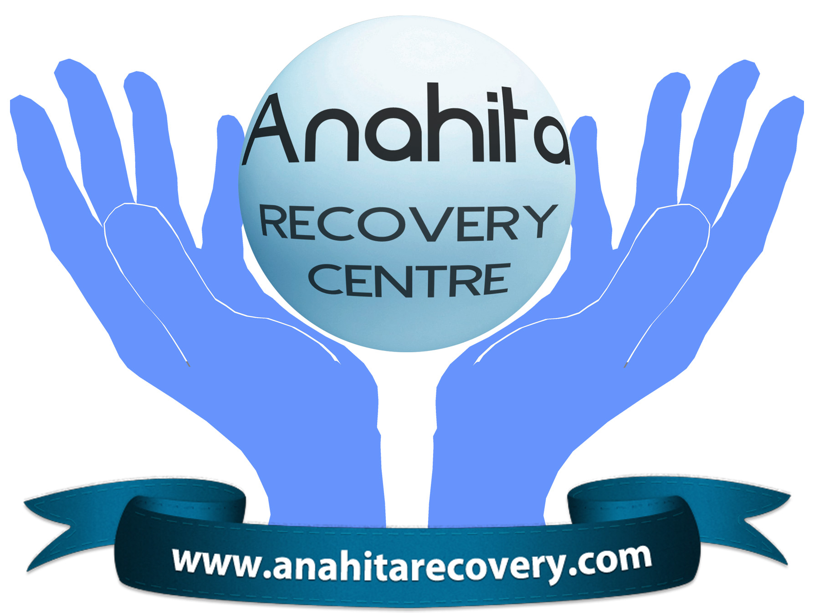
ANAHITA RECOVERY CENTRE LLP

MENTAL HEALTH

APPLICATION

PACK

PLEASE FIND FOLLOWING:

GUIDANCE TO HELP YOU MAKE YOUR APPLICATION (2 PAGES)

APPLICATION FORM (4 PAGES)

EQUAL OPPORTUNITIES (2 PAGES)

PLEASE DO NOT COMPLETE THE DOWNLOADED APPLICATION FORM IN MICROSOFT WORD AS IT UPSETS THE PAGE FORMATTING.

PLEASE PRINT OFF THE BLANK FORM AND COMPLETE BY HAND.

ANAHITA RECOVERY CENTRE LLP

MENTAL HEALTH

Guidance to help you when making your application

These guidance notes are designed to assist you in completing your application. All information you write is confidential.

The decision to shortlist you for interview will be based solely on the information you provide on your form so it is important that you complete the form as accurately and as fully as possible.

Please complete the form in black ink or type, as it will be necessary to photocopy your application form. If you also wish to include a CV, we recommend that this should be a maximum of three sheets of A4.

You will need to complete the top section of the application form using the following information, which can be found on the website.

Job Title

Ref. No

Closing Date

Please will you also include your e-mail address and that of your referees if appropriate?

Please kindly inform your referees that they will be contacted for a reference. As sometimes a reply is needed before the interview date if you are shortlisted.

Job Description and Person Specification

The Job Description outlines the main purpose and duties of the job. The Person Specification identifies qualifications, experience and skills, which are necessary for the job and the criteria against which you will be selected for interview.

Education, Training and Qualifications

Make sure you give all the information needed, including dates of study, making clear the level of examinations e.g. GCSE, GCE, ‘O’ Level or ‘A’ Level etc., and the grades obtained. Also include any special skills training; short courses or relevant work placements.

References

Your principal referee should be your present employer/tutor. A second referee is required from somebody who can testify as to your suitability for the type of employment for which you have applied e.g. past employer/tutor. Both referees will be contacted before interviews take place, unless you clearly state otherwise. We are unable to accept references from friends or colleagues.

Employment History

Write here the name and full address of your present and past employers and the dates you were employed by them. Please give a full career history including any temporary, part-time, or voluntary/unpaid work. Please give reasons for any gaps in employment.

Additional Information

This is the most important section. You should explain your reasons for making this application and your interest in this area of work. You must demonstrate how you meet each of the criterion identified in the Person Specification, drawing on your past experience and highlighting the skills you have gained and developed as a result. These should then be put into context by providing specific examples. Include any activities outside of work that may be relevant e.g. voluntary, community or charity work, leisure interests, membership of professional/other organisations or caring for relations.

If you use additional sheets, please number them clearly and print your name at the top of each sheet – remember to sign the form.

To be considered for this post your completed application form must be received at Anahita Recovery Centre by 5pm on the closing date.

If you have not heard from us within 4 weeks of the closing date, this would indicate that your application has been unsuccessful on this occasion. However, you are most welcome to apply for future advertised positions within Anahita.

IF YOU REQUIRE ANY FURTHER ASSISTANCE YOU CAN CONTACT: -

The Manager, 104 Gavestone Rd, Lee, London SE12 9BL. Telephone 020 8857 2077 email - manager@anahitarecovery.com

We look forward to receiving your completed application.

ANAHITA RECOVERY CENTRE LLP

MENTAL HEALTH

IN CONFIDENCE

Position Applied for: |  | Reference No: |  | Closing  Date:

Please Return To: The Manager
Anahita Recovery Centre
104 Gavestone Rd,
Lee, London, SE12 9BL

PERSONAL DETAILS
Mr |  | Mrs |  | Ms |  | Miss |  | Dr

Surname

Forenames

Address

Telephone No. (home) |  | Telephone No. (work)

Mobile Number |  | E-mail

Date of birth |  | Do you possess a valid & current driving license? | Yes |  | No

REFERENCES
Please give the names and full addresses of two referees. These should include your present employer or last employer if currently unemployed. Students should give the names of head teacher, tutor or Professor as appropriate. We are unable to accept references from friends or colleagues.
Title |  | Title

Name |  | Name

Address |  | Address

Tel. No. |  | Tel. No.

Fax No |  | Fax No

E-mail |  | E-mail

Relationship to applicant |  | Relationship to applicant

May we approach the above, May we approach the above
Prior to interview? | Yes |  | No |  | Prior to interview? | Yes |  | No
EDUCATION TRAINING AND QUALIFICATIONS

Secondary Education
Place of education |  | From |  | To |  | Subject |  | Education Results
 |  |  |  |  |  |  |  | Level |  | Grade |  | Date

Further Education
Place of education |  | From |  | To |  | Subject |  | Education Results
 |  |  |  |  |  |  |  | Level |  | Grade |  | Date

Professional
Name of Professional Body |  | Membership Grade and/or Registration & Pin No. |  | How gained  Full/Part Time |  | Date

Training please include any short course or relevant in-service training
From |  | To |  | Course/Subject |  | Qualifications

EMPLOYMENT HISTORY
Please give career history including any periods of voluntary/unpaid work and reasons for any gaps in employment.
Name and full address of present or most recent employer
Job Title

Salary/Grade |  | From |  | To
Reason for leaving

Names of previous employers and nature of business  (Starting with the most recent) |  | Position Held |  | From |  | To |  | Reason for Leaving
ADDITIONAL INFORMATION
Drawing on your experiences/skills/abilities and qualifications, please demonstrate how you meet the Person Specification and explain what makes you suitable for this position. Address each criterion in turn. Include details of any relevant unpaid or voluntary work (see Guidance Notes). Continue on a separate sheet if necessary.

Disclosure of Information
Because of the nature of the work for which you are applying, this post is exempt from the provisions of Section 4(2) of the Rehabilitation of Offenders Act, 1974, by virtue of the Rehabilitation of Offenders Act (Exceptions) Order 1973. Applicants are, therefore, not entitled to withhold information about convictions which, for other purposes, are 'spent' under the provisions of the Act, and in the event of employment, any failure to disclose such convictions could result in dismissal or disciplinary action by ARC LLP. Any information given will be completely confidential and will be considered only in relation to posts to which the order applies.

Do you have any convictions to disclose? If YES, please give details:

Are there any proceedings currently being investigated against you? If YES, please give details:

DECLARATION

I understand that all appointments are subject to medical clearance and satisfactory references.

If successful, I agree to a Criminals Records Bureau check at the appropriate level for this post.

I certify that the information contained in the application is correct and understand that failure to disclose any information could result in termination of my contract, should I be successful in this application.

Signature |  | Date

ANAHITA RECOVERY CENTRE LLP

MENTAL HEALTH

EQUAL OPPORTUNITIES – RECRUITMENT MONITORING
Anahita Recovery Centre is actively seeking to recruit people currently under represented in the workforce. This includes people from ethnic minorities and people who have experienced mental health problems.
In order to help us monitor the effectiveness of our policy, please complete this form. The information will be used solely for monitoring purposes and treated as strictly confidential. It will be separated from your application form before any consideration of candidates takes place. Any complaints that applications for employment have been unfairly considered may be made in writing to the manager at Anahita Recovery Centre.
Please tick relevant box | Mr |  | Mrs |  | Ms |  | Miss |  | Dr

Sex: Male |  | Female |  | Marital Status

Surname |  | Forenames

CHILDREN AND DEPENDENTS
The Equal Opportunities Commission recommends that information on children and dependents should be collected on monitoring forms, to ensure that there is no discrimination against applicants with dependents.
Number of children | Age | 0-4 years |  | 5 – 16 years

Other dependants
(please specify)

ETHNIC ORIGIN: Please tick the category which you feel best describes your ethnic origin:
WHITE |  | BLACK OR BLACK BRITISH
British |  | Caribbean
Irish |  | African
Any Other White Background |  | Any Other Black Background
MIXED |  | ASIAN OR ASIAN BRITISH
White and Black Caribbean |  | Indian
White and Black African |  | Pakistani
White and Asian |  | Bangladeshi
Any other Mixed Background |  | Any Other Asian Background
OTHER ETHNIC GROUPS
Chinese
Any Other Ethnic Groups
Not Stated

CITIZENSHIP

If you are not a British Citizen or European Community National, is there any restriction placed on the length of time that you may stay in the United Kingdom?
Yes |  | No |  | Do you require a work permit? | Yes |  | No |  | N/A

If you answer yes to either question please specify. Give details on a separate sheet and attach it to your application

DISABILITY

Do you have a disability that you wish to tell us about? | Yes |  | No |  | N/A

Please use this space for any comments:

MENTAL HEALTH

Please tick the appropriate box to indicate what mental health problems you have experienced.
None
Problems treated solely via primary care services, at GP surgery, in private counselling/psychotherapy or through self help support

Referred to psychiatric services for out-patient or in-patient treatment.

Please use this space for any comments:

Disclosure of Information
Are you related to a Director or a senior employee of this Limited Liability Partnership? |  | Yes |  | No

RECRUITMENT PUBLICITY

From what source did you learn about this vacancy?

What did you think about the quality of the recruitment information you received?

Excellent |  | Good |  | Fair |  | No comment

Please use the space for any comments:

